Save Manager
3.x Documentation

Carter Games

Documentation

Documentation Contents
Documentation 1
Dependencies 2
Asset Settings 2
Navigation Menu Options 2
Edit Settings 2
Save Editor 2
Save Object Creator 2
Save Objects 3
Save Values 3
Save Locations 3
Save Structure 4
Json Converters 6
Meta-data 6
Save Backups 6
Save Encryption 7
Legacy (2.x) Save Porting 7
Pre Data Load Intercept 7

The save manager is a flexible & modular save system for the Unity game engine with a built-in save editor to edit the save without needing to open the save file itself.

Dependencies
The save manager requires the Newtonsoft Json package to function. This can be added to your project for free by adding the following package in the package manager from inside a Unity project:
com.unity.nuget.newtonsoft-json

Asset Settings
All of the asset settings can be found in the project settings menu under:
Carter Games > Assets > Save Manager

The settings can also be accessed under the navigation menu item:
Tools > Carter Games > Save Manager > Edit Settings

Navigation Menu Options
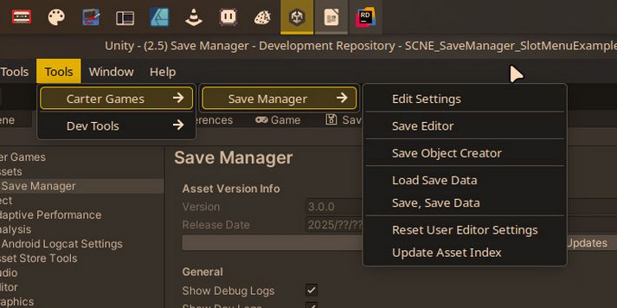

Edit Settings | Opens the settings if it is not already focused on in the editor.
Save Editor | Opens the save editor window to let you access and edit the save data from the editor.
Save Object Creator | Opens a GUI popup to aid in the creation of Save Object classes.
Load Save Data | Loads the current save location manually.
Save, Save Data | Saves the current save state to the save location.
Reset User Editor Settings | Resets any per-user settings related to the asset to their default values.
Update Asset Index | Updates the assets asset lookup in-case of any issues. Should be ignored, but is there for debugging.

Save Objects
A save object is basically a scriptable object that can store save values on it. When defined the save values on each object can be access in the editor and at runtime with ease. To make a save object you just need to make a class that implements the SaveObject class, or SlotSaveObject class if you want the data to be specifically used in save slots.

You can do this manually by making a class that inherits from the SaveObject clases or you can use the built-in SaveObject maker GUI. This can be found under:

Tools > Carter Games > Save Manager > Save Object Creator
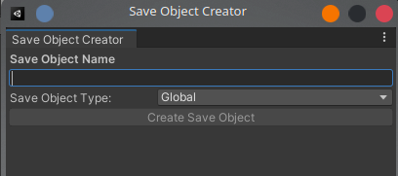

The save object creator window has a really simple set-up. You first enter the name of the class you want to make into the Save Object Name field on the GUI. Then if you have the Save Slots feature enabled you’ll be able to select between a global or slot save object. If not then it’ll be global by default behind the scenes and the option will be hidden from you.

Then all you need to do is press the Create Save Object button and choose where in the project’s assets folder the class should go. Once you confirm the location for the class it will be generated automatically for you.

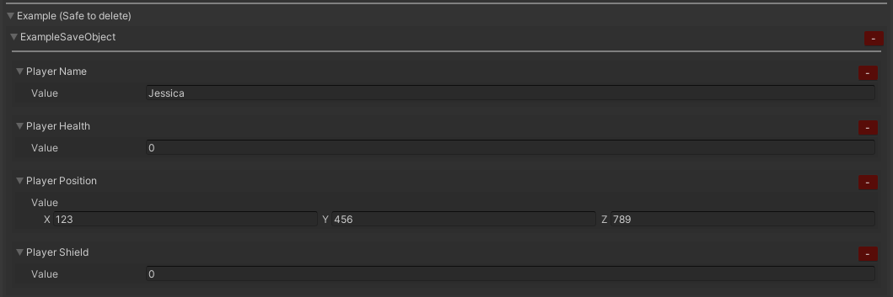
All correctly set-up save values can be viewed in the Save Editor window. Either under the Global Data or Save Slots tab dependant on which Save Object class it is under. An example from the example save data:

Save Values
A save value defines an entry in the game save. You define save values by using the generic save value class SaveValue<T> as a field on in a SaveObject class. A valid save value MUST:

- Be placed inside of a class that inherits from SaveObject/SlotSaveObject, if not it will not function correctly.
- Be of a serializable type.
- Have a uniquely defined save key.

You have the option to also define a default value for the save value if you wish, but this is totally optional.

An example of a defined save value below:

[SerializeField] private SaveValue<int> lastTimestamp = new SaveValue<int>("lastTime");

Save Locations
The asset provides a couple different save locations to use. These are:

Local File | Stores the save data in a file in the application persistent data path.
Player Prefs | Stores the save data in Player prefs, but split into chunks so it can all be saved.

You can define custom storage locations should you wish by implementing the following interfaces into your own classes:

IDataLocation | To define a location where data can be saved to or loaded from.
ISaveDataLocation | To define a DataLocation that can be used to save/load the game save data specifically.

You can change the location that is used in the asset settings at any time. However, if you have a released product, it is advised you keep the same location throughout to avoid any issues with changing between the different locations. A change in location will be handled on the next load if the previous is different to the currently set.

Editor Save
The editor has a separate save file to your built runtime. This is so you can edit the save in the editor freely without conflict with a build version of your game on the same machine. The editor save will be stored in your projects persistent data path under the /EditorSave folder. This can be accessed from the asset settings open folder option next to the editor save path label:

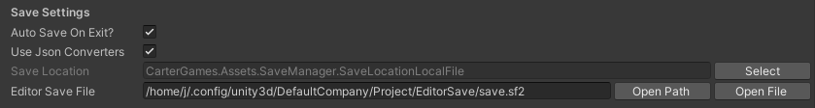
The editor save will update on certain conditions to avoid performance hits when making edits. These are:
- Saving the project
- Closing Unity
- Entering play mode (pressing play in editor)
- Script recompilation

The editor save will also only save when there are changes to be saved.

Save Structure
The 3.x save structure divides the content of the save into a few different sections. The main game save is stored under the $content tag. It is then split the following:

$global | Any game save data that is not used for the save slots system.
$slots | Sores info about the slots system as well as the data for all the slots themselves.

There is also an additional section under the $metadata tag which stores read-only info for context about the game & the users system which is completely optional.

Each save value defined is split into a object with 3-4 tags per entry. These are:

$key | Defines the key the save system has defined for the value.
$value | Holds the Json value.
$type | The type the save value is.
$default | Defines the custom default value for the save value. Only appears if defined.

An example:

{
"$key": "examplePlayerHealth",
"$value": 6,
"$type": "System.Int32",
"$default": 10,
}

An example of a fully populated save data below:

{
"$content": {
"$global": [
{
"$key": "examplePlayerName",
"$value": null,
"$type": "System.String"
},
{
"$key": "examplePlayerHealth",
"$value": 10,
"$type": "System.Int32"
},
{
"$key": "examplePlayerPosition",
"$value": {
"x": 1.0,
"y": 2.0,
"z": 3.0
},
"$type": "UnityEngine.Vector3"
},
{
"$key": "examplePlayerShield",
"$value": 5,
"$type": "System.Int32"
}
],
"$slots": {
"$settings": {
"$slots_available": true,
"$slots_defined": 1,
"$slots_last_active": -1
},
"$slot_1": {
"$slot_save_date": "2025-12-24T10:18:16",
"$slot_playtime": "0",
"$slot_data": [
{
"$key": "exampleSlotBool",
"$value": false,
"$type": "System.Boolean"
},
{
"$key": "exampleSlotString",
"$value": “test”,
"$type": "System.String"
}
]
}
}
},
"$meta_data": {
"$game_info": {
"$version": "0.1.0",
"$save_date": "2025-12-24T10:18:16"
},
"$system_info": {
"$os": "Linux 6.17 Fedora Linux 42 64bit",
"$cpu": "AMD Ryzen 7 5800X 8-Core Processor",
"$ram": "32006MB",
"$gpu": "AMD Radeon RX 6800 (RADV NAVI21) (16368MB)"
}
}
}

Json Converters
The save manager set-up automatically saves any serializable fields which are either:

- public exposed fields
- [SerializeField] private fields

These values need to also be serializable in Unity for them to be saved.

This is a custom set-up that only select fields as the standard set-up for Newtonsoft Json, which the asset uses for its Json set-up, is to serialize both fields and properties. You can freely edit the Json of any of your custom types by making a converter class that inherits from the SmJsonConverterBase<T> class.

Meta-data
Meta-data is extra data that is added to a separate section of the game save. The purpose is to show important info such as game version & basic system info to aid with debugging etc. This section of the save is never encrypted, so it is always readable. If no meta-data can be written to the save then the section will be omitted from the save entirely.

The asset has two default implementation that are enabled by default. You can disable them in the asset settings with a simple toggle for each one.The GameInfo meta-data class displays the save date & version number from the player settings. While the SystemInfo meta-data displays the OS/CPU/RAM/GPU info of the users system.

You can easily make your own meta-data set-ups to add to the save by making a new class that implements the ISaveMetaData interface.

Save Editor
The save editor is the intended way for you to edit the save of your game. You can open the save editor window from the navigation menu’s Save Editor option.

Save Backups
The asset will automatically store one or several backups of your save data when it loads without errors when the data is different to the last stored in a backup. In the event a save fails to load it will instead try to load a backup. If all backups fail to load you’ll get an GameLoadFailed (1210) error code.

You can view save backups from the editor with the save editor window in the save backups tab:

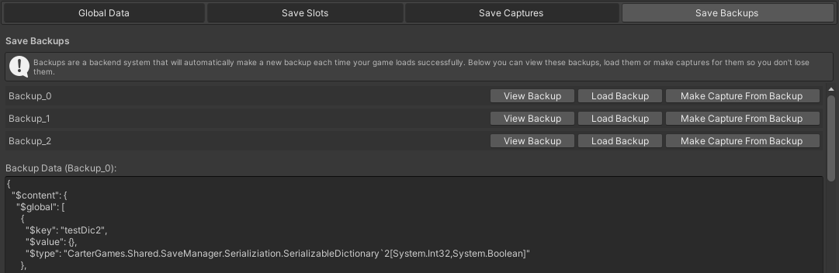
Here you can view the backups and perform a few actions:

View Backup | Displays the backup save data in the GUI to view.
Load Backup | Tries to load the backup as the current save data in the editor.
Make Capture From Backup | Tries to make a save capture from the backup data so it is not lost when new backups are made.

Save Encryption
You can encrypt the save content with the built-in set-up. This will encrypt the content data only. So meta-data will still be readable as this is intended for read-only info. By default this set-up is disabled.

The asset provides a super basic AES encryption handler to encrypt the save if you wish. This isn’t super secure and any determined attacker will easily get through it. The average user would not be able to read the save right away though.

You can also implement your own encryption set-up by making a class that implements the ISaveEncryptionHandler interface. This is recommended if you want a more secure save as I cannot package the best solutions without adding more dependencies or more complex set-ups.

Legacy (2.x) Save Porting
The asset comes with a basic set-up that should port and 2.x save data into 3.x global save data where the keys & types match between versions. It won’t work for slot save data due to the legacy set-up not supporting such a feature.

The set-up will try to port a legacy save if one is found and then move it once processed to a legacy location as a backup. This set-up is enabled by default, but can be disabled in the asset settings.

If you want to add your own implementation of a porting of your 2.x save data, you can make a class implementing the ILegacySaveHandler interface.

Pre Data Load Intercept
You can add logic before the game loads new data from the save by making a class that implements the IPreSaveDeserialize interface. This lets you edit the Json from the save before it is converted into Json object to load it into the game. This is mainly useful for porting older save set-ups to new structures etc. Using this set-up is risky as it can break the loading process easily. Use at your own risk.

Scripting
Below is a small summary of the main API you’ll be accessing from the asset. Note that I’ve only included the intended API for you to use and not every public property and/or method.
All classes for the asset at runtime are under the following:
Assembly:
- CarterGames.SaveManager.Runtime
- CarterGames.Shared.SaveManager (Optional, may be needed for some API)
Base Namespace:
- CarterGames.Assets.SaveManager

The asset is set-up in the mind that you’ll be leaving the editor set-up be as most won’t ever need to mess with it.

Main Scripting API
Scripting 9
Save Manager 10
IsInitialized [Property] 10
IsSaving [Property] 10
IsLoading [Property] 10
IsBusy [Property] 10
InitializedEvt [Evt] 11
GameSaveStartedEvt [Evt] 11
GameSaveCompletedEvt [Evt] 11
GameLoadStartedEvt [Evt] 11
GameLoadedEvt [Evt] 11
GameLoadFailedEvt [Evt] 11
GameLoadFailedCompletelyEvt [Evt] 12
SaveGame [Method] 12
LoadGame [Method] 12
GetGlobalSaveObject [Method] 12
TryGetGlobalSaveObject [Method] 12
GetActiveSlotSaveObject [Method] 12
TryGetActiveSlotSaveObject [Method] 13
GetSlotSaveObject [Method] 13
TryGetSlotSaveObject [Method] 13
TryGetSaveValue [Method] 13
TryGetGlobalSaveValue [Method] 13
TryGetActiveSlotSaveValue [Method] 13
Save Value 14
Value [Property] 14
ValueType [Property] 14
ValueObject [Property] 14
HasDefaultValue [Property] 14
DefaultValue [Property] 14
DefaultValueObject [Property] 15
ResetValue() [Method] 15
Save Object 16
Lookup [Property] 16
HasValue() [Method] 16
GetValue() [Method] 16
SetValue() [Method] 16
ResetObjectSaveValues() [Method] 16
SaveCategory [Attribute] 16

Save Manager
The save manager class is the main API class which you’ll use. It is a partial class for readability so the different sections of the class are in different files.

IsInitialized [Property]
public static bool IsInitialized { get; }

Gets if the save manager class has fully initialized. You should check this before accessing the other API as if the asset is not initialized you may get unexpected errors.

IsSaving [Property]
public static bool IsSaving { get; }

Gets if the save manager is currently saving data.

IsLoading [Property]
public static bool IsLoading { get; }

Gets if the save manager is currently loading data.

IsBusy [Property]
public static bool IsBusy { get; }

Gets if the save manager is currently running a save or load operation.

InitializedEvt [Evt]
public static readonly Evt InitializedEvt

Is raised when the save manager has initialized.
Add a listener to receive the evt when it is raised.

GameSaveStartedEvt [Evt]
public static readonly Evt GameSaveStartedEvt

Is raised when the save manager has started to save data.
Add a listener to receive the evt when it is raised.

GameSaveCompletedEvt [Evt]
public static readonly Evt GameSaveCompletedEvt

Is raised when the save manager has completed saving data.
Add a listener to receive the evt when it is raised.

GameLoadStartedEvt [Evt]
public static readonly Evt GameLoadStartedEvt

Is raised when the save manager has started to load data.
Add a listener to receive the evt when it is raised.

GameLoadedEvt [Evt]
public static readonly Evt GameLoadedEvt

Is raised when the save manager has started loaded data successfully.
Add a listener to receive the evt when it is raised.

GameLoadFailedEvt [Evt]
public static readonly Evt<LoadFailInfo> GameLoadFailedEvt

Is raised when the save manager has failed to load a data set for any reason.
Add a listener to receive the evt when it is raised.

GameLoadFailedCompletelyEvt [Evt]
public static readonly Evt GameLoadFailedCompletelyEvt

Is raised when the save manager has failed to load data from the current save or any existing backups. Add a listener to receive the evt when it is raised.

SaveGame [Method]
public static void SaveGame()

Saves the game in its current state when called.

LoadGame [Method]
public static void LoadGame()

Loads the game from the stored save data when called.

GetGlobalSaveObject [Method]
public static T GetGlobalSaveObject<T>()

Gets the global save object of the defined type. For a safer call, please use the TryGetGlobalSaveObject method instead.

TryGetGlobalSaveObject [Method]
public static bool TryGetGlobalSaveObject<T>(out T saveObject)

Tries to gets the global save object of the defined type. It returns the result of the call so you can catch any issues instead of dealing with null values.

GetActiveSlotSaveObject [Method]
public static T GetActiveSlotSaveObject<T>()

Gets a save object from the currently active slot of the defined save object type. For a safer call, please use the TryGetActiveSlotSaveObject method instead.

TryGetActiveSlotSaveObject [Method]
public static bool TryGetActiveSlotSaveObject<T>(out T slotSaveObject)

Tries to get a save object from the currently active slot of the defined save object type. It returns the result of the call so you can catch any issues instead of dealing with null values.

GetSlotSaveObject [Method]
public static T GetSlotSaveObject<T>(int slotId)

Gets a save object from the defined slot id of the defined save object type. For a safer call, please use the TryGetSlotSaveObject method instead.

TryGetSlotSaveObject [Method]
public static bool TryGetSlotSaveObject<T>(int slotId, out T saveObject)

Tries to get a save object from the defined slot id of the defined save object type. It returns the result of the call so you can catch any issues instead of dealing with null values.

TryGetSaveValue [Method]
public static bool TryGetSaveValue<T>(string saveKey, out SaveValue<T> value, SaveCtx ctx = SaveCtx.Unassigned)

Tries to get a save value from anywhere in the save. Use SaveCtx to define the placement of the value in the save data set-up for a slightly faster call.

TryGetGlobalSaveValue [Method]
public static bool TryGetGlobalSaveValue<T>(string saveKey, out SaveValue<T> value)

Tries to get a save value from just the global save set-up in the save.

TryGetActiveSlotSaveValue [Method]
public static bool TryGetActiveSlotSaveValue<T>(string saveKey, out SaveValue<T> value)

Tries to get a save value from just the active save slot in the save.

Save Value
public SaveValue(string key)
public SaveValue(string key, T defaultValue)

Defines a value that is stored in the game save. All save values MUST have a save key assigned to them for the system to save them. Any without a key will be flagged in the editor and not be saved to the save data until corrected.

Value [Property]
public T Value { get; set; }

The value stored in the save value. Use to access or edit the actual value stored in the save.

ValueType [Property]
public Type ValueType { get; }

The type the save value is, mainly used for the asset itself. But it is public if you wish to use it.

ValueObject [Property]
protected object ValueObject { get; set; }

The object-typed value for the saved value. Please use T Value for accessing the save value instead of this.

HasDefaultValue [Property]
public bool HasDefaultValue { get; }

Gets if a default value has been set to this save value. Will return false if the default value is the type default.

DefaultValue [Property]
public T DefaultValue { get; set; }

Defined the default value of the save value. You can set this post constructor if you wish to. Default values are stored in the save along side the current value.

DefaultValueObject [Property]
protected object DefaultValueObject { get; set; }

Like the value object variant it is the object-typed value for the saved default value. Please use T DefaultValue for accessing the save default value instead of this.

ResetValue() [Method]
public void ResetValue(bool useDefault = true)

Reset the value to its user defined default if there is one set, or to its type default value if there is no defined default value.

Save Object
Defines a scriptable object that can contain save values that the save manager will detect and handle.

Lookup [Property]
public Dictionary<string, SaveValueBase> Lookup { get; }

A lookup that is generated when first accessed. It stored a key lookup of all the save values contained on the save object for access. Mainly used by the assets own API, but you can also use it if you wish.

HasValue() [Method]
public bool HasValue(string key)

Gets if the save object has a save value defined on it with the entered key.

GetValue() [Method]
public SaveValue<T> GetValue<T>(string key)

Gets a save value on the save object that matches the entered key.

SetValue() [Method]
public void SetValue(string key, object value)

Sets a save value on the save object that matches the entered key to the entered value.

ResetObjectSaveValues() [Method]
public virtual void ResetObjectSaveValues()

Another API intended for the assets own use. You may use this method to reset all save values on the save object if need be.

SaveCategory [Attribute]
[SaveCategory("ExampleSaveCategory")]

A save object specific attribute that allows you to define a save category for a save object to go under in the save editor GUI.

Listener Classes
You can listen to some of the assets set-up by implementing specific interfaces without needing any extra logic, these are:
Listeners
Listener Classes 17
IGameSaveListener 17
IGameLoadListener 17

IGameSaveListener
Implement to list to when the game saving is called to start and completed.

IGameLoadListener
Implement to list to when the game loading is called to start and completed or fails.

Extending the asset
You can extend the save manager by making your own implementations for core features of the asset to use. These can then be selected in the asset settings so the asset uses them over the default provided options. It is recommended you test any custom implementations well before releasing them for public use in-case of issues. When developing any custom locations or encryption set-ups it is advised to save a backup of your game data to a alternative location so you can restore it should issues arise.

Extension API
Extending the asset 18
IDataLocation 19
HasData [Method] 19
SaveToLocation [Method] 19
LoadFromLocation [Method] 19
ISaveDataLocation 20
DataLocation [Property] 20
HasSaveData [Property] 20
SaveDataToLocation [Method] 20
LoadDataFromLocation [Method] 20
ISaveBackupLocation 21
Location [Property] 21
BackupData [Method] 21
GetBackups [Method] 21
ISaveEncryptionHandler 21
Encrypt [Method] 21
Decrypt [Method] 21
SmJsonConverterBase 22
ReadFromJson [Method] 22
WriteToJson [Method] 22
ISaveMetaData 23
Key [Property] 23
CanWriteMetaData [Property] 23
GetMetaData [Method] 23
ILegacySaveHandler 23
ProcessLegacySaveData [Method] 23

IDataLocation
Implement this interface to define a location at which any data can be stored at. Implement along-side ISaveDataLocation to define a custom save data location.

HasData [Method]
public bool HasData(string path)

This method should return if the data location has any data currently stored or not.

SaveToLocation [Method]
public void SaveToLocation(string path, string data)

This method should save the entered data to the location.

LoadFromLocation [Method]
public string LoadFromLocation(string path)

This method should load the data from the location.

ISaveDataLocation
Implement this interface to define a custom game save data location to store your game save data at. This requires a IDataLocation implementation to be set-up for the desired location as well.

DataLocation [Property]
public IDataLocation DataLocation { get; }

Should get the IDataLocation implementation to use for this save method.

HasSaveData [Property]
public bool HasSaveData { get; }

Should get if there is save data stored in the location currently.

SaveDataToLocation [Method]
public void SaveDataToLocation(string json)

This method should save the entered json to the location when called.

LoadDataFromLocation [Method]
public string LoadDataFromLocation()

This method should load the json from the location when called and return the received data.

ISaveBackupLocation
Implement this interface to define a location at which any save backups may be stored. This requires a IDataLocation implementation to be set-up for the desired location as well.

Location [Property]
public IDataLocation Location { get; }

Should get the IDataLocation implementation to for the backups.

BackupData [Method]
public void BackupData(JToken data)

This method should save the entered data to the location.

GetBackups [Method]
public IEnumerable<JObject> GetBackups()

This method should load all the backups from the location for use.

ISaveEncryptionHandler
Implement this interface to make your own data encryption handler to use with the asset.

Encrypt [Method]
public string Encrypt(string contentData)

This method should encrypt the data entered into it and return the result of the encryption back to the system for use.

Decrypt [Method]
public string Encrypt(string encryptedData)

This method should decrypt the data entered into it and return the result of the decryption back to the system for use.

SmJsonConverterBase
Implement this abstract class to add your own json converters so the save manager can use them when saving your data. By default all public fields or private fields with the [SerializeField] attribute will be saved if possible. You should implement a custom converter if a custom type is not saving correctly or you need to save a Unity type that is not saving correctly in the current set-up.

ReadFromJson [Method]
protected abstract void ReadFromJson(ref T value, string name, JsonReader reader, JsonSerializer serializer)

This method should read the json value for the required field if applicable. This should be done through a switch statement or similar.

An example from the Vector2 converter set-up:

protected override void ReadFromJson(ref Vector2 value, string name, JsonReader reader, JsonSerializer serializer)
{
switch (name)
{
case nameof(value.x):
value.x = (float)reader.ReadAsDouble().GetValueOrDefault(0d);
break;
case nameof(value.y):
value.y = (float)reader.ReadAsDouble().GetValueOrDefault(0d);
break;
}
}

WriteToJson [Method]
protected abstract IEnumerable<KeyValuePair<string, object>> WriteToJson(Vector2 value, JsonSerializer serializer)

This method should define what is written into the json and assign a key/value pair for each value that should be in the json.

An example from the Vector2 converter set-up:

protected override IEnumerable<KeyValuePair<string, object>> WriteToJson(Vector2 value, JsonSerializer serializer)
{
return new KeyValuePair<string, object>[]
{
new KeyValuePair<string, object>("x", value.x),
new KeyValuePair<string, object>("y", value.y),
};
}

ISaveMetaData
Implement to define extra data that is added to the $metadata tag in the save data structure. This is read-only and is mainly intended to aid in context info for debugging etc.

Key [Property]
public string Key { get; }

Defines the string key the meta-data is saved under.

CanWriteMetaData [Property]
public bool CanWriteMetaData { get; }

This property should define if the meta-data can be written to the save. Use to toggle the data off if you don’t need it etc.

GetMetaData [Method]
public JObject GetMetaData()

This should return all the values in a single object to write to the save when called. An example from the game info meta-data set-up:

public JObject GetMetaData()
{
return new JObject
{
["$version"] = $"{Application.version}",
["$save_date"] = DateTime.UtcNow.ToString("yyyy-MM-ddTHH:mm:ss"),
};
}

ILegacySaveHandler
Implement to define a custom solution to port older 2.x save manager saves to the 3.x set-up. By default the asset will try to port all 2.x save data to 3.x global data where the keys match. You can implement this interface to change that to something custom should you wish.

ProcessLegacySaveData [Method]
public JToken ProcessLegacySaveData(JToken loadedJson, IReadOnlyDictionary<string, JArray> legacyData)

This method should return the processed data, adding the legacy data into the loaded json to produce the converted result.

